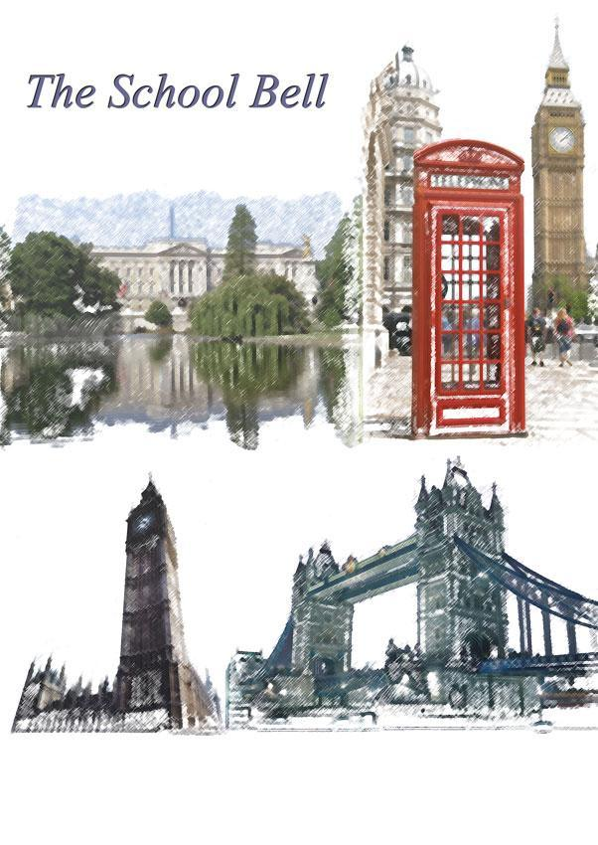

The School Bell
Časopis za osnovnoškolski uzrast na engleskome jeziku
Broj 3

Osnovna škola Ivana Gorana Kovačića
Vrbovsko
Osnovna škola Ivana Gorana Kovačića Vrbovsko

The School Bell
Časopis za osnovnoškolski uzrast na engleskome jeziku
Broj: 3/2015.

Za izdavača: Anton Burić, prof.

Glavni urednik: Biljana Ivošević, dipl.uč.

Naslovna stranica: Davorka Nekić, prof.

Lektura: Biljana Ivošević,dipl.uč.

My toys

Hi! I'm Lucy and these are all my lovely toys.
This is my new lion.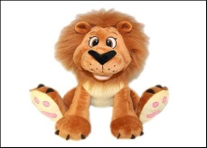 It's brown.
This is my new mobile phone.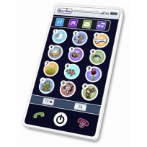 It's very nice.
That's my horse 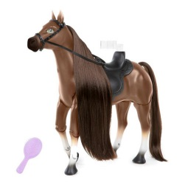and that's my smurf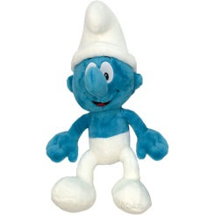.
This is my doll Merlia.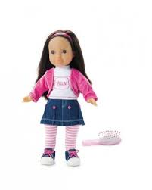 Merlia is my favourite toy!

Lucija Dujmović, 3rd class, Vrbovsko

ANIMALS
Across: | Down:
1-It's working hard on it's net.  3- It can see at night. It likes to catch a mouse.  4- It has a cute body. It eats bamboo.  6- It's small. It lives in Antarctica. It's black and white.  7- It's the people's best friend.  8- It can jump. It lives in Australia.  11-It's very small and boring.  13- It's a very, very slow animal.  14- It's scary. It has very big mouth. It's green.  15- It has got big ears. It likes to eat carrots.  My daily routine | 2- It's very clever. It can swim very well.  3- It's very fast. It lives in Africa. It's yellow and black.  5- It's big and white. It likes to eat fish.  9- It’s funny. It likes bananas.  10- It's very tall. It has got a long neck.  12- It's very strong. It lives in Africa. It's brown and orange. It's a king of all animals.  4th class, Vrbovsko

I wake up at nine o clock on Sundays. I have cereals for breakfast. After breakfast, I change my clothes and I go out and play. I have lunch at noon. Then I go to play with my friend. At five o'clock I have shower, I put on my pyjamas and watch TV. I go to sleep at ten o'clock.

Dorotea Marojević, 4th class, Vrbovsko

On Saturday, I get up at ten o’clock. I eat breakfast at half past ten, then I watch TV or meet my my friends. In the afternoon, I am usually at home and I study. I have dinner at seven o’ clock. After dinner, I watch TV. I go to bet at eleven.
Saturdays are fun!
Maya Bradić, 5th class, Vrbovsko

On Saturdays, I get up at 10. I have breakfast at 11 o’clock. At 12 I go out and play with my friend. At 1 I go home and I have lunch at half past one. At 2 o’clock, I meet my friend. After that, I play video games. In the afternoon I watch TV. I have dinner at 6. After dinner, I have a chat with my friends on Facebook. I go to bed at 11.
Saturdays are fun!
Ema Vujnović, 5th class, Vrbovsko My dream house

My Deream house
My dream house is in Paris near to the Eiffel Tower. It has got five floors and outside is a big garden, garage and swimming pool. Inside, there is a kitchen, four bedrooms, living room, bathroom and a library.
My room is green and it has got a TV, a huge bad, wardrobe, desk, chair and four windows. Kitchen is very big. Living room has got a big sofa and an armchair, a big TV, fireplace, a lamp and a carpet. The bathroom is very comfortable. Library is big and there are lots of books.
I love my dream house because it is big and I love it a lot.
Maya Bradić
Class: 5
OŠ Ivana Gorana Kovačića Vrbovsko

My dream home

My dream home is in Paris. It has got four floors and outside there is a swimming pool. Inside, there is a huge living room with a fireplace, a modern kitchen, six bedrooms and four bathrooms. My favourite room is the big TV room. It has got a sofa, big TV, a DVD player and a CD player. It’s very cosy there.
My dream bedroom is very cool. Everything is black and green. I’ve got a bed, a desk, a wardrobe, a computer, a DVD player, a big TV and a bookcase. I have got a bathroom just for me.
I like my dream home because it’s beautiful. It’s a fantastic home.
Leona Krajačić
Class: 5
OŠ Ivana Gorana Kovačića Vrbovsko

I'm from Croatia

Hi! I'm Luka and I'm from Croatia.
Zagreb is the biggest city in my country. The river Sava is the largest river and Risnjak is the highest mountain in my country. Krk is the biggest island in our Adriatic sea. The most famous lakes are Plitvice lakes. It's a national park.
A nick name of Croatia is “The country with a thousand islands”.
Luka Mužević, 4th class, Vrbovsko

Hi! I’m Leone and I’m from Croatia.
Zagreb is the biggest city in my country. It’s the capital, too. The Sava is the longest river and Velebit is very a long mountain. Castle Trakošćan is beautiful castle near Varaždin.
My Croatia is beautiful.
Leone Poljak, 4th class, Vrbovsko

CROATIA- GREAT DESTINATION
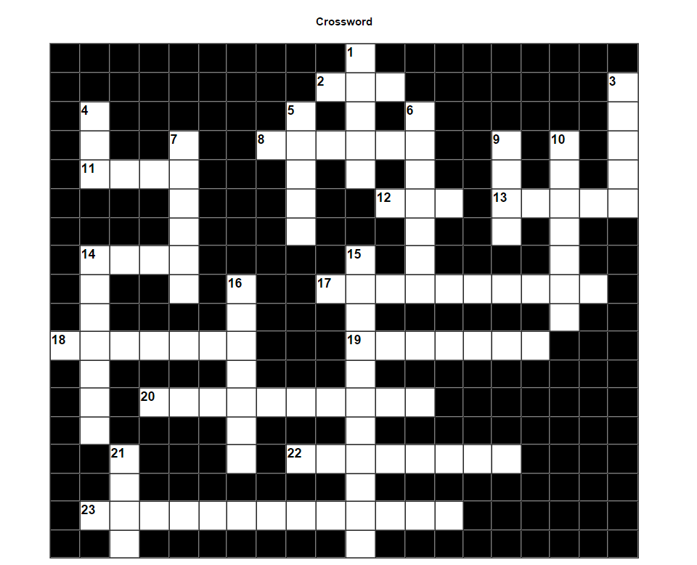

Across: | Down:
2- The smallest city in Croatia.  8- The highest mountain in Croatia.  11- National park in Dalmatia.  12- Island famous for delicious cheese and beautiful lace.  13- The biggest city in Dalmatia.  14- The most famous beach in Croatia.  17- A big swamp in Slavonija.  18- National park in Gorski kotar.  19- The most famous street in Dubrovnik.  20- Mountain near Zagreb.  22- What do the Croatians speak?  23- National park with 16 lakes. | 1-The biggest river in Croatia.  3- National park near Dubrovnik.  4- The biggest island in the Adriatic sea.  5- Famous Dalmatian dance.  6- Region between the Drava and the Dunav.  7- The capital of Croatia is…  9- Traditional food in Dalmatia.  10- Long mountain near the sea.  14- The snowiest mountain in Croatia.  15- You can spend your winter holiday there.  16- ''Hero city'' in Slavonija.  21- You can see the Arena there.  8th class Vrbovsko
MARTINJE-THE LOCAL CELEBRATION
Martinje is a big fair in Vrbovsko. It takes place on 11th November every year.
Before the fair, sellers mark their place for their stands. There are always a lot of stands, from the beginning to the end of Vrbovsko's main street. On that day, kids get from school earlier. A lot of people from all around Gorski kotar come to Martinje. People usually sell clothes, fruit, toys, meat… Also, the prices are lower than in the mall in a big city. I always go to the fair with my mum and aunt. We often find really cute clothes for really good prices. My dad buys some pork for lunch on the fair. Grandmas loves big amounts of fruit and flowers that are there. Martinje usually lasts from the morning to the afternoon. This year it ended earlier because of the rain.
However, people always go home with a lot of stuff and smiles on their faces. I really like Martinje.
Lara Mužević, 8th class, Vrbovsko
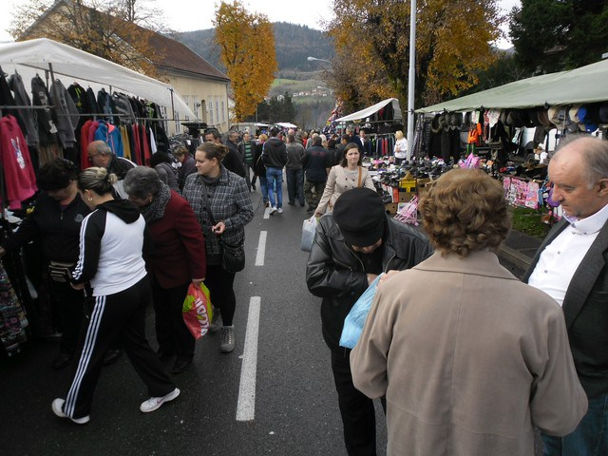

School trip

Last Tuesday we went to Zagreb with our teacher and pupils from Severin na Kupi and Moravice.
We visited the ZOO. There are a lot of big and small animals. Our favourite animals are crocodiles.
We visited Gornji grad and we saw a big cathedral. We had a great time together, but at the end of day, we were very tired.
Class: 4, Vrbovsko
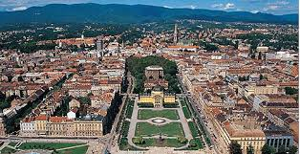

COUNTRY life VS CITY life
Dear Emma,
I live in Vrbovsko, Croatia and I like it. In my country there are so many beautiful places. My two favourites are Vrbovsko and Zagreb.
Vrbovsko is small city in the part of Croatia called Gorski Kotar and it is in the mountain area. It is much quieter than Zagreb. There is a beautiful nature all around. In winter, there is a lot of snow. All my friends live in Vrbvsko and that is the reason why I like it.
On the other hand, Zagreb is the capital of Croatia and it is about 100 kilometres far away from Vrbovsko. It is the
biggest city in our country. There are a lot of shops,
museums, theatres, buildings, restaurants, hotels and people, too. I like going to the cinema there and driving by tram.
Write me please about two favourite places of yours in your country. I would like to know more about your place of living.
Write me soon,
Iva
Iva Mufic, 6th class, Vrbovsko

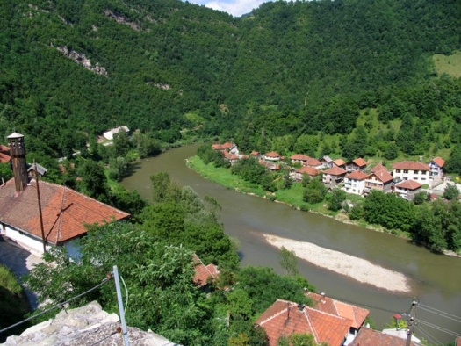
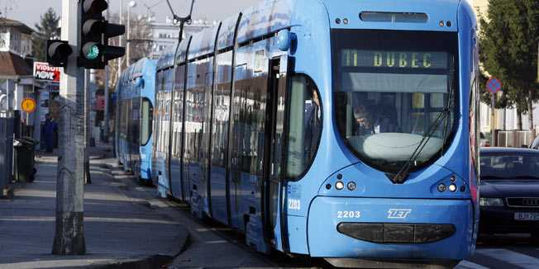

City life and country life have their advantages and disadvantages. There are a lot of differences in many aspects like environment, jobs and number of people.
In a village you have many things which make life easier and prettier. Advantages of a country life are: beautiful nature, clean air, hospitable people, home-made food... The biggest disadvantage of a country life is isolation. Everyone has to have their own car to travel to work or something else important for life. There aren't enough shops, so you can't buy anything you want. It is very complicated to find a good job, too.
On the other hand city life is much faster and tiring. Advantages of a city life are: everything is close and is never boring, lots of shops and jobs, public city transport, modern life and big choice of a jobs and schools. Disadvantages of a city life are: streets are crowded and much noisier, air is polluted and there aren’t lots of green areas.
If you ask us, country life is much better and nicer because in villages there are cute animals, clean air, rivers, meadows and local celebrations.

Doris Peulić, Maja Ninković, David Kosanović
8th class, Vrbovsko
What can we do?

For me, war and homelessness are the most serious problems in the world because people die and get ill. We need to stop wars so that people have easier lives.
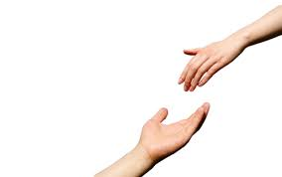
Arsen Vukušić
I think that the two most serious problems are war and famine. War destroys the Earth and famine is a result of war and we must donate money or food to those in need.
Aleksandra Stipanović
Black or white skin is no reason for discrimination. We are all people and if someone doesn't like someone because of his appearance does not mean that he is stupid or less value. Skin colour does not have to mean anything. Don’t look what is outside but look in the inside.
Valentina Halilović
I think that war and famine are the most serious problems. Because of war, people die and war causes that children are hungry and die. I think that we should donate food and money.
Maja Ninković
The most serious social problems are war and famine. War is a big problem because it destroys the Earth. We need to help, but we can't destroy their traditions or divide their tribes. Famine is generally a result of war. We must help people by donating money and food.
Doris Peulić
Most serious problems are unemployment and poverty. We need to help people by helping them to get a job.
Tea Božić
I think that the most serious problems are war and poverty because people are hungry, poor and die frequently. We need to help people by giving them food, money and clothes. We need to stop the fighting.
David Kosanović
For me, endangered animals and illiteracy are the most serious problems because if all endangered animals die we will lose the beauty of our world. Illiteracy causes unemployment, then homelessness, then poverty, and then famine and disease.
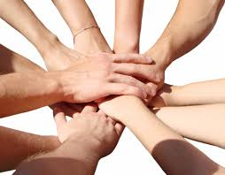
Jakov Burić
The biggest two problems are war and famine. When people are hit by war, they die in big numbers, they can stay crippled for whole life and people can also die of hunger.
Wendy Jardas
The biggest two problems are homelessness and unemployment. When someone is unemployed, the whole family can die because of hunger.
Magdalena Matovinović
To me, the most serious problems are diseases and racial discrimination. We need to stop racism so that people can live normal lives. Disease can kill a lot of people.
Tea Musulin
For me the most serious problems are war and poverty because in war many people die and in poverty they don’t have any food or homes. We need to stop wars that people can live better.
Patricia Matjašec
Even though World War II finished, there are still a lot of wars around the world. For an example there are so many wars in Africa, Syria and Afghanistan and people live in fear because of the war. The reason is mostly because of oil.
There are a lot of people who live in luxury houses and have a huge amount of money, but there are still people who barely have something to eat. There are a lot of foundations who try to help those people, but there are too many people in need, especially in Africa. There are more and more people who live in poverty and I´m afraid that we can't help them all.
Lara Mužević

Class: 8 ,Vrbovsko

