THE POWER OF GARLIC

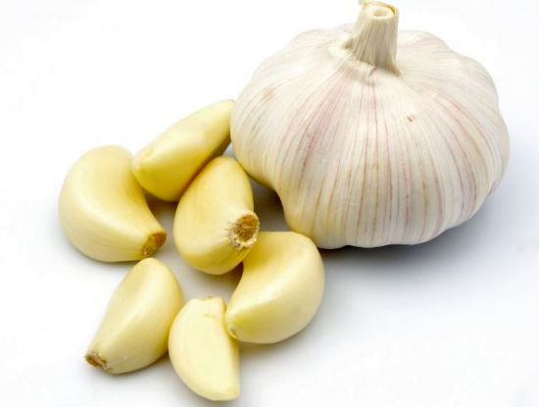

Brochure about the power of garlic with practical recipes for using in everyday life

MADE BY:
Pupils of Primary school Ivan Goran Kovačić Vrbovsko, Regional school Ivan Goran Kovačić Severin na Kupi with their teacher Jasmina Krakar
Special thanks to Laura Mufić

THE BENEFITS OF GARLIC

Garlic is a plant of very strong and acidly taste, famous for its top level in culinary art and for its medical characteristics.
The main substance of garlic is allicin which contains miracle antibacterial, anitviral, antifungal, antiparasitic and antioxidant effect.

It originates from Mediaeval Asia and it is one of the oldest cultivated plants in the world which is grown for over 5000 years.
It seems that the Egyptians first started growing this plant which had important role in their culture. Egyptians considered garlic as sacred plant, and it was found in the tombs of pharaohs. They also knew about healing properties of garlic so they were giving it to slaves to improve their strength and resistance to illnesses.
Healing properties of garlic were also well known by the ancient Greeks and the Romans whose athletes ate garlic before sporting competitions. Before they went to war, Greek and Roman soldiers consumed garlic to improve endurance and resistance to illnesses.

RECIPES WITH GARLIC
Garlic is used in approximately 17126 recipes. The easiest way of enjoying in the taste of garlic is in combination with bread. Spread the mixture of butter, salt and crushed garlic on bread and then put it in the oven under the heated upper heater. If you like Italian bruschetta, use toasted bread and grease it with the cleaned clove of garlic. After that add chopped tomato in cubes, some salt and basil and enjoy in taste.
Garlic is gladly used spice in all Mediterranean cuisines. Fresh garlic is most often used in roasted, boiled or stewed dishes, whereby its intensive flavour taste reduces.
If the garlic is sliced, shredded or crushed, it is used for making warm sauces for pasta, goulash or soups. Uncleaned cloves of garlic, and even the whole bulbs can be baked with meat. It can be used in desserts, even in the ice cream. Garlic can be preserved in oil or vinegar. You can use garlic powder for preparing marinades.
In our national cuisine there are also various uses of garlic. As a spice, it is used with preparing cured meat products, freshly chopped is added to cottage cow's cheese, stews, mushroom dishes, baked meat and other dishes.
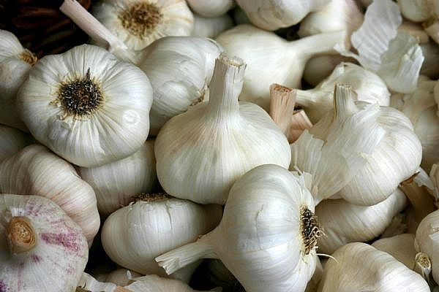

GARLIC AND LEMON
USE: It eliminates deposits in the blood vessels – heart surgery is not required. If the vessels in the brain or heart vessels are narrowed or clogged, take one little glass of potion which is made of 30 cleaned and finely chopped cloves of garlic and 5 uncleaned and finely chopped lemons.
RECIPES: Mix all ingredients in the blender, add 1 litre of water and boil the mixture. Let the mixture boil only once!!! Drain, pour in the bottle (you get about 1 litre of liquid) and keep in cold place.
CONSUMING: Take one little glass a day, as you wish, before or after the main meal. According to supporters of this therapy, after only 3 weeks of everyday use, you can see or feel youthful recovery of the whole body. Occlusion of blood vessels and side effects with eyesight and hearing are progressively retreating and little by little they disappear. After three-week’s therapy, you need to take a break of 8 days, and after that you can start new three-week’s therapy. Only in this way you can accomplish the real effect. This cheap harmless and healing therapy can be repeated every year. Unpleasant scent of garlic nobody notices, but the effects of garlic and lemon got the acknowledgement. People who suffered from occlusion can finally sleep peacefully. The person can avoid heart surgery, because blood fat and accumulation in the veins are removed. The garlic potion can be used even with periodontitis.

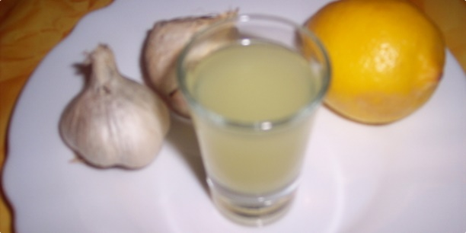

GARLIC AS A CURE FOR WARTS
After you have thoroughly washed your hands, peel one clove of garlic and cut it in half. Take one half and spread it over the wart with the sectioned side, so the juices would completely cover it. Spread it on for about a minute or two. Then, take the other sectioned half and put it on the wart and put the patch or a sticky tape on it. Take care that the garlic is bigger than the wart.
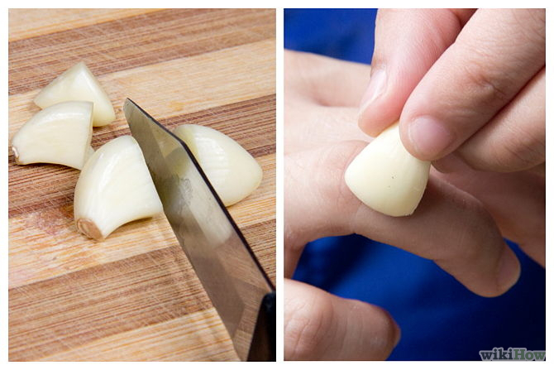
Garlic is easily spread on the wart.
You can also make mash of garlic, you can crush it with a fork, squash it or scrub it, just be careful that the mixture is larger than the size of a wart so you can cover it completely. Put the mixture on a plaster and stick it on a wart. This natural way for treatment of warts and corns apply before you go to bed, and then remove it during the day to allow breathing space for skin, and continue again with fresh garlic every night.
For smaller warts or corns, healing with garlic will often lead to complete healing within a week. For bigger warts, maybe you will have to continue with this healing during a couple of weeks.
There are some conventional treatments for healing the warts which includes lining of salicylic acid, cryotherapy, operational and laser procedures and other pharmaceutical medicines but even though all these procedures can remove warts, they don't destroy the virus itself and just because of that, garlic is effective. Many studies confirm this, as well as customer experiences, so there are no obstacles why shouldn't you try this ancient cure for all on warts too.

TREAT THE COUGH WITH GARLIC

Garlic juice is very effective natural cure against cough, which you can make by following this recipe:

INGREDIENTS: 1 bulb of garlic, 2-3 spoons of natural honey

PREPARATION: Take 1 nice and healthy middle sized bulb of garlic. Peel it off and cut in small pieces. Put it in a deep bowl and cover with honey. Cover the bowl with some saucer or foil and leave it on a room temperature overnight. Tomorrow morning, strain the mixture through a thick gauze or a strainer. This is a dose for one day. Take 1 spoon of syrup every 2 hours, even often if you like. Surely, after a short while, you will feel that you breathe more easily, and soon you will start to expectorate.
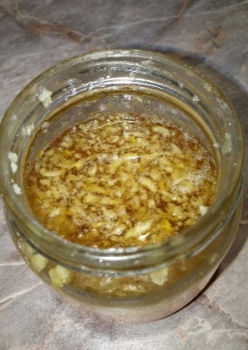

GARLIC SYRUP AGAINST THE FLU

If your skin is sensitive, maybe it’s the best that you wear gloves while preparing this tonic. Make sure that you don’t touch your eyes when you make this tonic because they can be irritated by the natural garlic oils.

INGREDIENTS:
- ½ chopped red onion
- 5 cloves of chopped garlic
- 2 red chilli peppers (chopped)
- 1 chopped spoon of ginger
- juice of 1 squeezed lemon
- apple cider vinegar

How to make it?
You will need a middle sized jar (350 – 500 ml). Add chopped onion in it, and garlic too. Subsequently add chilli peppers with seeds and the put ginger on top. In the mixture, add squeezed lemon juice, and at the end, pour everything into apple acid vinegar. Make sure that you have at least 1 centimetre of empty space at the top. Close the cover tightly and save the cure in a cold dark place. You can start consuming the tonic the next day already. This mixture is an excellent fighter against the flu, the cold or sore throat.

GARLIC LOWERS THE TEMPERATURE
This is an ideal thing for children. If you child has got a high temperature, chop the garlic in circles and soak it in apple acid vinegar. Then put it on child's feet and in child's ears. The temperature disappears very quickly.
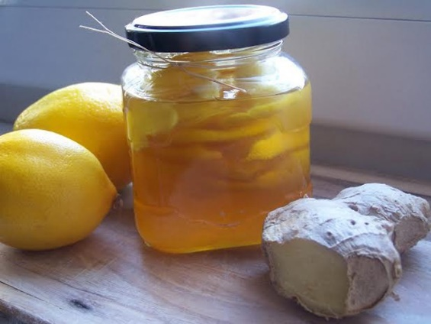
HOW TO MAKE GARLIC TINCTURE FOR REJUVENATION AND DETOX AT HOME

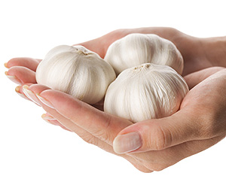
In 1971. in the ruins of Tibetan monastery 5 thousand years old inscription on clay plates was found. That inscription was translated in world's languages, and it contained a recipe for curative miracle garlic tincture which rejuvenates and revitalizes whole human body. To intensify its effectiveness, chilli peppers were added to the tincture.
This miracle Tibetan tincture heals:
- atherosclerosis
- hypertension
- lungs diseases
- arthritis and rheumatism
- visual and hearing disorders
- impotence
- lack of appetite
- gastritis
- stomach ulcer and haemorrhoids
- cleanses the body of fat
- Rinse calcified deposits
- improves metabolism
- dissolves blood clots
- regulates body weight
- and most important: reduces internal and external tumours
RECIPE FOR GARLIC TINCTURE
INGREDIENTS:
- 350 grams of garlic
- 220-250 grams of 90% ethyl edible alcohol
- 3-4 chilli peppers (if you wish)
PREPARATION:
While preparing, use bowls and tools made of wood, porcelain or glass. Chop the garlic and chilli peppers, put them in a jar and cover with alcohol. Close tightly and leave it in a fridge for 10 days.
Shake it every day, and supervise it while it's becoming greenish. After 10 days, strain the tincture tightly through a gauze and leave it for 3 days more days in the fridge and then you can start your therapy.
Table of tincture taking
20 minutes before every main meal take provided dose of tincture stirred in some domestic milk or water. After you reach the dose of 25 drops, continue in that way until you complete the tincture.
DAY | BREAKFAST  (number of drops) | LUNCH  (number of drops) | DINNER  (number of drops)
1. | 1 | 2 | 3
2. | 4 | 5 | 6
3. | 7 | 8 | 9
4. | 10 | 11 | 12
5. | 13 | 14 | 15
6. | 15 | 14 | 13
7. | 12 | 11 | 10
8. | 9 | 8 | 7
9. | 6 | 5 | 4
10. | 3 | 2 | 1
11. | 25 | 25 | 25
REFERENCE:
Therapy with garlic tincture can be repeated only after 2-5 years. If you have gastric problems or you take medicines, especially anticoagulants, consult your doctor before the beginning of a therapy.
In the first days, there may be mild difficulties because of body detoxification like rash, dizziness, headache or stomach pain. If the symptoms don't reduce in 2-3 days, you should stop taking the cure.
TIBETAN ELIXIR FOR BODY REJUVENATING
This mixture of garlic, honey and lemon in Tibetan medicine is a famous elixir which successfully slows the aging process.
INGREDIENTS:
- 10 bulbs of garlic
- Juice of 10 lemons
- 1 kg of honey
PREPARATION:
Chop 10 bulbs of garlic in small pieces and mix them with 1 kilogram of honey and juice of 10 lemons. Pour the mixture into a jar, cover it and leave it for 8 to 10 days. After that, take 1 spoon of this natural elixir twice a day, in the morning on an empty stomach and in the evening before the last meal. These preparations are used for cleaning blood vessels, relaxation and organism rejuvenation.
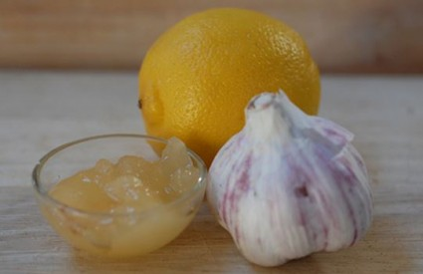

TIBETAN POTION FOR HEALTH OF THE HEART AND BLOOD VESSELS
The preparation is used for cleaning blood vessels from fat deposits gradually and for prevention of heart attack and stroke. It also stops creation of tumours, it improves eyesight and rejuvenates the organism.
INGREDIENTS:
- 1 kilo of organically grown lemon
- 300 grams of garlic
PREPARATION:
Grate the lemon (together with peel) and garlic. Put the mixture in 1,5 litres of boiling water and in covered pot boil in light fire for 15 minutes. Chilled preparation pour into a jar and close it with a cap. Take 0,5 decilitre of the preparation on an empty stomach for 25 days. After that take a break of 10 days and then repeat the therapy. In order of prevention, you can take the therapy once to twice a year, every six months. In order to heal, take the therapy until the improvement of health situation, with mandatory compliance of protocol by taking 10 days break before starting another therapy.

GARLIC REMOVES EARACHE AND HEADACHE
Earache is very unfavourable phenomena, but with the help of garlic, you can take the pain away in the blink of an eye. How?
Simply put 1 cleaned clove of garlic into your ear. The clove perfectly fills into your ear, like a suppository. The pain and otitis stops in few minutes, and the feeling of warmth spreads through your ear.
It works!
Your headache will also pass with this. In that case, repeat this procedure before going to sleep. Let the garlic stay in your ear overnight. In the morning, you will be as good as new.

GARLIC MILK AGAINST THE PAIN IN THE BACK

INGREDIENTS: 2 dcl of milk, 2 cloves of garlic

PREPARATION: Cut or mash the garlic and leave it for 10 minutes. Preheat the milk that it is very warm, but not hot. Put the garlic in it, leave it for 20 minutes, stir well and strain. Throw away the garlic, and drink milk.

USE: Drink once or twice a day during two weeks.

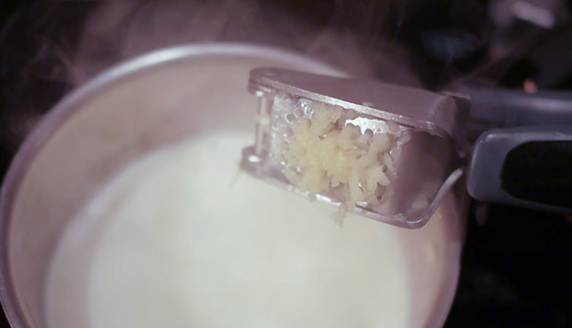

FLOUNDER UNDER THE SKIN

A small piece of wood which slips under the skin is hard to get out, but with the help of garlic put on a painful spot and covered with a plaster, the flounder will easily come out.

HAIR LOSS

Garlic is famous by its beneficial effect on scalp recovery so if you are losing your hair, rub you scalp with garlic oil several times a week or even with the garlic itself and leave it work for at least 10 minutes.

COUGH SYRUP

Garlic operates like antibiotic so it can help in fight against cough. Finely chop two cloves of garlic and put them in 1 decilitre of hot water, leave it stand for a few minutes, and then drink like tea.

SKIN CARE

Allicin, the compound in garlic helps soften the skin and makes it smooth. Add some smashed garlic into your face mask, keep it on for a few minutes longer than expected and then rinse it in lukewarm water. Clean complexion and fresh look are the results of this easy procedure.

REMEDY FOR ACNE

One of the benefits of garlic is definitely his beneficial effect on beauty. In other words, garlic juice heals acne and pimples. It is enough to smash 2 cloves of garlic and put the mixture on the painful spot. The results will be visible after only a few minutes when the swelling around the pimple reduces.

