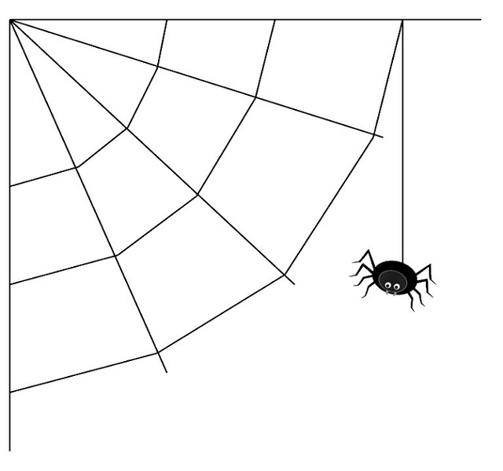
Little Spider's First Web

A big spider saw a little spider.
The little spider was spinning a web.
It was her first web.
The big spider got on his web.
And he began to swing.

A fly saw the big spider on his web.
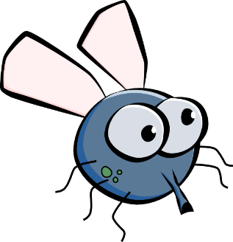
He said,
“Why do you swing, big spider?”
“I swing because little spider
is spinning her first web.”
The fly said,
“Then I will buzz.
I will buzz and buzz.”

A bee heard the fly buzz.
She said,
“Why do you buzz, little fly?”
“I buzz because little spider is spinning her first web.”
The bee said,
“Then I will hum.
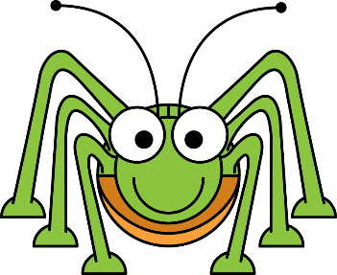
I will hum and hum.”

The cricket heard the bee hum.
He said,
“Why do you hum, little bee?”
I hum because little spider is spinning her first web.”
The cricket said,
“Then I will chirp.
I will chirp and chirp.”
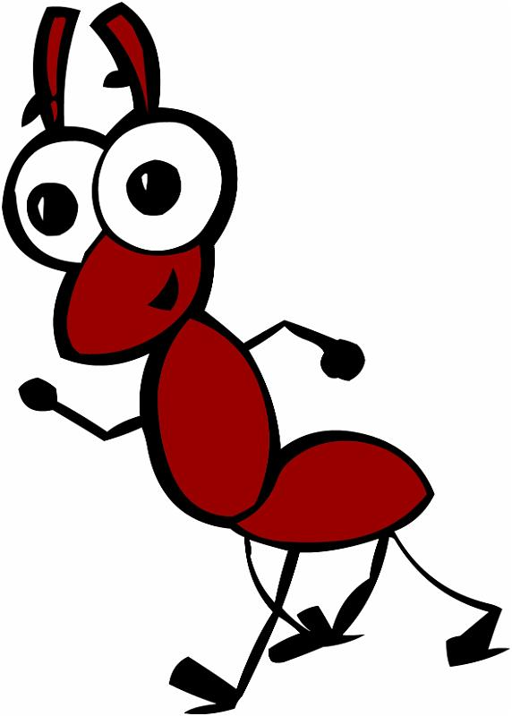
The ant heard the cricket chirp.
She said,
“Why do you chirp, cricket?”
I chirp because little spider is spinning her first web.”
The ant said,
“Then I will run to and fro.
I will run and run.”

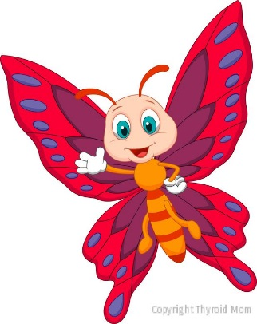
A butterfly saw the ant run to and fro.
She said, “Why do you run to and fro?”
“I run because little spider is spinning her first web.”
The butterfly said,
“Then I will fly.
I will fly and fly.

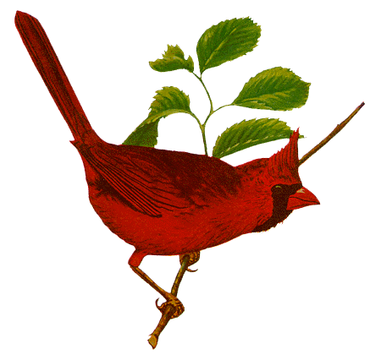
The bird saw the butterfly.
She said,
“Why do you fly, butterfly?”
“I fly because little spider is spinning her first web.”
The bird said,
“Then I will sing.
I will sing and sing.
I will make the children happy.”

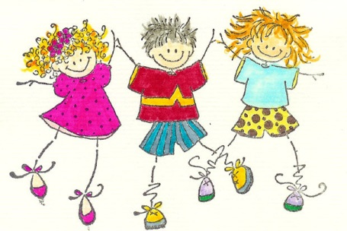
The children heard the bird sing.
They saw the butterfly fly.
They saw the ant run to and fro.

They heard the cricket chirp.
They heard the bee hum.
They heard the fly buzz.
They saw the big spider swing on his web.
They saw the little spider spinning her first web.
The children were happy.

